**Web Application for Breast Cancer Prediction**

**Objective:** The main aim of this project is to implementing a web application for breast cancer prediction and providing existing predicted reports to users.

**Abstract:** Breast cancer is one of the most common and major causes of cancer in women. Currently, it has become a common health problem and recently its incidence has increased. Early detection is the best way to manage breast cancer results. Computer-aided detection or diagnosis (CAD) systems play a major role in early detection of breast cancer and can be used to reduce mortality in women. The main purpose of this paper is to make use of recent advances in the development of CAD systems and related technologies. The main theme of the project is to assess whether a person is suffering from breast cancer. Machine learning is nothing more than training machines to learn and operate on their own without any explicit program or instruction. So here, whether a person is suffering from breast cancer or not can be assessed with the help of trained data.

.

**Keywords:** Breast cancer, Prediction,

**Existing System:** In an existing system, it is important for physicians to diagnose various conditions related to Brest cancer Detection at an early stage because early detection can prevent or reverse kidney damage. Early detection can provide better treatment and proper care for patients. Many regional hospitals / clinics have a shortage of nephrologists or general practitioners to diagnose symptoms.Over time, companies will be able to implement the proposed machine learning framework in regional clinics with less medical professional retention, providing early diagnosis to patients in regional areas. This process can take a long time and is even more costly.

.**Disadvantages:**

* Time efficiency is high
* Have manual work is high
* It is costly

**Proposed System:** In proposed system, we are predicting the breast cancer using Existing records. In this we are initially collect the existing records then store into our system. Then we predict the results for Brest cancer based on their parameter values. This procedure can be have taken less time and cost sufficient.

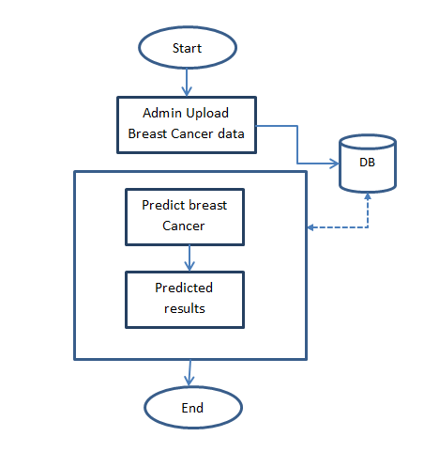

**Fig. Block diagram of proposed method**

**Advantages of proposed system:**

* Less time efficiency
* Reducing manual work
* Less cost

**MODULES:**

**Admin:** admin login with valid credentials. Upload Existing recorders. View users. Add new record.

**Users:** Users initially register with their details then login with registered details, predict breast cancer and view their existing predicted results.

**Software & Hardware Requirements:**

# **H/W System Configuration:-**

# Processor - I3/Intel Processor

* RAM - 4GB (min)
* Hard Disk - 500GB

**S/W System Configuration:-**

* Operating System : Windows 7/8/10
* Application Server : Tomcat 7.0
* Front End : HTML, JSP
* Scripts : JavaScript.
* Server side Script : Java Server Pages.
* Database : My SQL 6.0
* Database Connectivity : JDBC

**LEARNING OUTCOMES:**

* Knowledge about on Breast Cancer
* Data set collection from available sites
* Use of HTML and CSS on UI Designs.
* Data Base Connections.
* Data Parsing Front-End to Back-End.
* Need of Eclipse-IDE to develop a web application.
* Working Procedure.
* Testing Techniques.
* Error Correction mechanisms.
* How to run and deploy the applications?
* Introduction to basic technologies used for.
* How project works.
* Input and Output modules.
* How test the project based on user inputs and observe the output?
* Project Development Skills:
  + Problem analyzing skills.
  + Problem solving skills.
  + Creativity and imaginary skills.
  + Programming skills.
  + Deployment.
  + Testing skills.
  + Debugging skills.
  + Project presentation skills.
  + Thesis writing skills.